Technical Design Document Template

# Revision History

|  |  |  |
| --- | --- | --- |
| Version | Description | Date |
| 1.0 | Initial document | 6/08/20 |
| 1.1 | Added diagrams of AI Behaviour | 19/08/20 |

# Development Environment

## IDE

Visual Studio

## Source Control

Git

## Third Party Libraries

Raylib

## 2.4 Other Software

Tiled

# Game Overview

## Technical Goals

* 60 FPS
* Challenging AI
  + Attack the moment it sees the player and its attack is ready
  + Flee if sees the player and its attack is not ready
* Complicated map
  + Rooms look similar
  + Doors are hard to see because the player is moving to fast

## Game Objects and Logic

* Sonic the Hedgehog
  + Behaviour:
    - Keyboard
    - Stun
    - Attack
  + Purpose:
    - The players character
* Shadow the Hedgehog
  + Behaviour:
    - Wander
    - Seek Chaos Emerald
    - Seek Health Pack
    - Seek Master Emerald
    - Stun
    - Attack
    - Flee
  + Purpose:
    - Opponent
* Chaos Emeralds
  + Purpose:
    - Main collectable item in the game
* Master Emerald
  + Purpose:
    - Finishing point for the game

## Game Flow

When the game starts, the player can choose whether they want to play as Sonic or Shadow. Then when the game starts the player can then move their character with the arrow keys. The player must gather all the Chaos Emeralds and then go to the Master Emerald first to win the game. If the AI gathers all the Chaos Emeralds and then go to the Master Emerald first, then the player loses. If all the Chaos Emeralds have been collected, and the player and the AI don’t have 7 Chaos Emeralds in total, then the player will have to hit the AI to steal a Chaos Emerald from it but the only way to hit the AI is with an attack that charges overtime. Once the attack is charged then the player can press the spacebar to attack the AI if it is in range.

# Mechanics

* Movement
  + Left Arrow Key to move left
  + Right Arrow Key to move right
  + Up Arrow Key to move up
  + Down Arrow Key to move down
* Attack
  + Spacebar to attack once the attack is ready
* Collect
  + Once the player is within reach of a Chaos Emerald, the Chaos Emerald will disappear, and the player’s Chaos Emerald count will go up by 1.

# Graphics

This game will be a top-down 2D race game with sprites that have no animation.

# Artificial Intelligence

## Wander

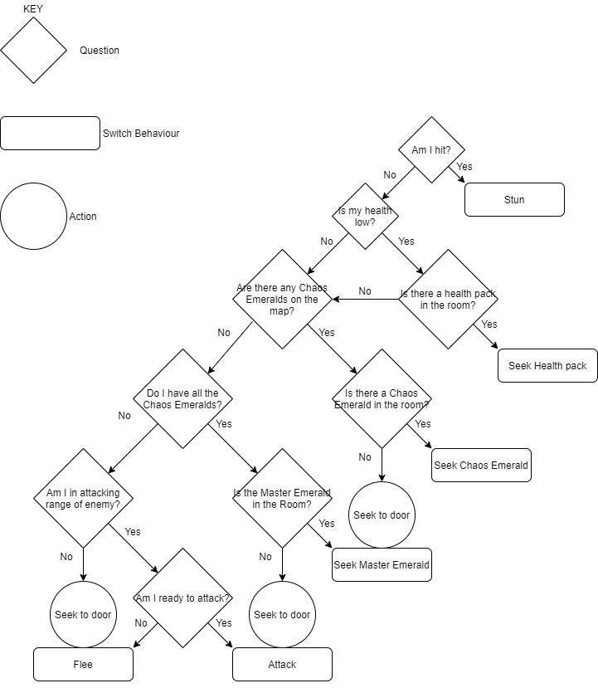

## Seek Chaos Emerald

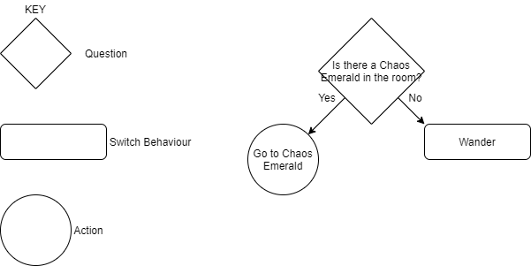

## Seek Health pack

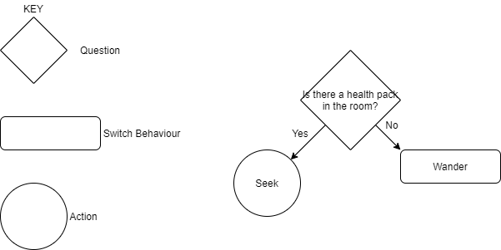

## Seek Master Emerald

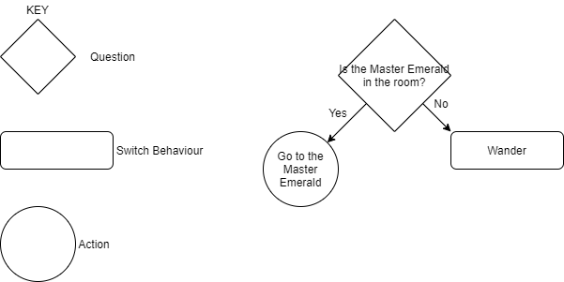

## Stun

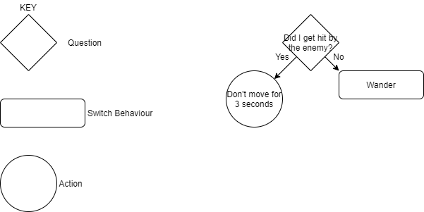

## Attack

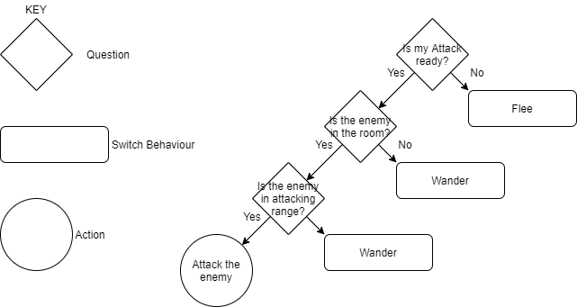

## Flee

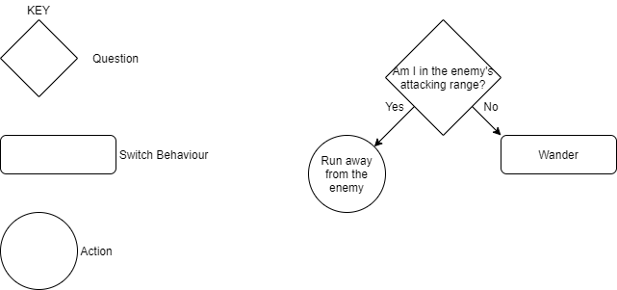

# Physics

I will be using Raylib’s collision methods to prevent the player and AI from going off the map.

# Items

|  |  |  |
| --- | --- | --- |
| Item | Description | Amount |
| Chaos Emerald | The main item that needs to be collected to win the game. | 7 |
| Master Emerald | The finishing point when the Chaos Emeralds are collected. | 1 |
| Health Pack | Restore health of the player or AI. Respawns 2 after they have been collected. | 2 |

# Game Flow

## ‘Level’ structure

The map will be loaded from a .png file. The borders will be created from Raylib’s rectangle, but they will not have any colour to conceal them from the player. The map’s rooms will be concealed and will be revealed once the player or AI enters the room. The map will be made through the Tiled app.

## Objectives

The players objective is to collect the 7 Chaos Emeralds and get to the Master Emerald.

# Levels

If the player or AI has all 7 Chaos Emeralds, the Master Emerald will change colour from dark blue to light green.

# Interface

## Menu

* Play
* Quit

## Camera

The camera will remain stationary and show the room that the player is currently in.

## Controls

The play state of the game will be controlled from the keyboard. The menu state will be controlled with the mouse.

# Asset List

* Chaos Emerald Sprites
* Master Emerald Sprite
* Sonic the Hedgehog Sprite
* Shadow the Hedgehog Sprite